**2024 Nutrition 10 Health Goal Assignment – Part 2 of 2** (25 points)

*Now that the quarter has come to an end, let’s reflect on your SMART health goal. You may wish to look at Part 1: Setting Your Goal, which you submitted in Week 2 of the quarter, in writing your responses.*

**Part 2: Reflecting on Your Experience**

1. What was your **one** health, nutrition, or fitness-related SMART goal you committed to and tracked for 4, 5, or 6 weeks of the quarter? *Copy and paste your answer from part 1 here and please make sure your goal is written using the SMART criteria if you didn’t receive full credit.*

Over the next six weeks, I will be completing at least two jogging workouts every weekend, completing at least 2 miles each time. I would do at least 120 minutes a week of moderate-intensity aerobic exercises, such as brisk walking or bicycling. In addition, strength training and flexibility training can be done to strengthen muscles and joints. Additionally, to increase my dietary fiber and protein intake, I will add an apple or banana to my daily breakfast plan and an appropriate portion of fish for dinner. Keeping at least two meals a day for a week with dietary fiber and protein helps the digestive system to form good circulation. Maintain a healthy diet with adequate protein, carbohydrates, fats, vitamins, and minerals. This one health goal I ultimately want to achieve is to maintain general health and adapt to the daily stresses of life by eating a balanced diet and exercising moderately.

2. Did you meet your goal?  Yes  No (check yes or no: 0.5 points)

If you met your goal, what helped you do so? If you didn’t meet your goal, why do you think you were unable to meet it? Please be thorough in your response. (4.5 points)

Over the past six weeks, I've managed to achieve my health goals. My friends have provided me with great help and support throughout the process of reaching my goals. For my weekend workouts, I use my phone's calendar app to remind me to do 60 minutes of outdoor exercise versus 60 minutes of indoor exercise, including moderate-intensity aerobic exercise such as brisk walking or biking, every Saturday and Sunday morning and afternoon, respectively. The hardest part for me is doing a 2-mile long run outdoors. I always feel short of breath halfway through the run. My friend taught me how to breathe regularly during my long runs so that I could stick to each 2-mile run and work with my friends. They taught me so many useful ways to exercise that I gained a lot and allowed me to achieve my health goals. In terms of my daily diet, the note-taking software I have been using to keep a detailed record of what I eat each day, including the ASA24 report has helped me a lot. I use these programs to keep track of my daily intake of dietary fiber and protein, to maintain a healthy diet, and ultimately to reach my health goals through a balanced diet.

3. Describe how you tracked your goal. You can also take a picture or screenshot of your tracking method and submit it with this assignment. If you were unable to track your goal, please explain how you could improve tracking goals in the future. (5 points)

In terms of exercise, I mainly use the Apple Watch's exercise software to record my daily exercise data, including time, exercise distance, calories burned, and real-time heart rate. It provides a very good record and summary of my daily exercise and helps me plan my next exercise goal or take a different approach to exercise. In terms of my daily diet, I mainly use the note-taking software and ASA 24 report to keep track of the protein, carbohydrates, fats, vitamins, and minerals I consume. I will adjust my daily diet based on the records to keep my intake balanced and track my daily nutritional intake goals.

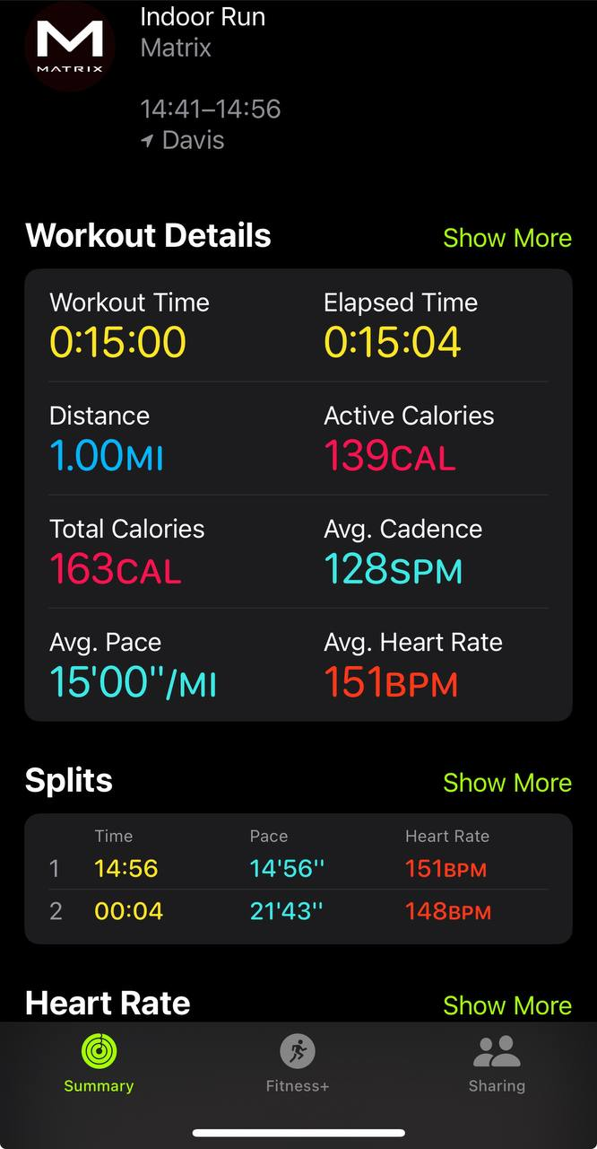

4. What did you find the most challenging while trying to meet your goal? Were you able to overcome this challenge? Why or why not? (5 points)

I think the most challenging thing for me in trying to achieve my goals is doing two-mile long runs twice a week, which is a very difficult part of the process for me. I have been able to overcome this challenging because my friends have been helping me and encouraging me. They have taught me how to breathe regularly during my runs and how to adjust the swing of my arms. If you want to train for running regularly for a long period, you should at least pay more attention to the way your feet land on the ground, your position, and you’re cushioning and propulsion. I have learned a lot in overcoming this most challenging difficulty and have been encouraged by my friends all the time to successfully overcome this difficulty so that I can successfully reach my health goals.

5. How did you use the information you learned in the lecture material to meet this goal? Discuss at least one topic from the lectures in your answer *(note: please do not write about the Food Diary Project or another assignment)*. (5 points)

The lecture on vitamins was one of the lectures that had an impact on my health goals and was one of the more interesting ones for me. The material in the lecture reintroduced me to the different classifications of vitamins and the importance of vitamins in food nutrition. For example, vitamin B12 can help balance the immune response and better fight viral infections. On the other hand, however, if too much vitamin D is consumed it can cause toxicity and may cause symptoms such as nausea and vomiting, weakness, and frequent urination. All the material from these lectures reminded me to balance my vitamin intake in my daily diet, and I made some modifications to the food plan in my health goals to try to cover as many of the various vitamins as possible in my daily diet. For example, I will reduce the amount of fish rich in vitamin D and fats and increase the daily dietary intake of meat rich in vitamin B12.

6. Based on your experience, what will you do differently in the future when it comes to setting and meeting health-related goals? Describe at least one change you plan to make. (5 points)

While I can accomplish the health goals I've set so far, I'm still currently consuming more daily fat than I'm burning daily based on the exercise data I've collected over these six weeks. So, in terms of setting and achieving health-related goals, I may increase my goals in terms of outdoor exercise in the future. For example, I will increase my goal of running two miles long every weekend to five miles and increase the frequency of exercise. On the other hand, I would also increase my daily 30-minute strength training, such as dumbbell training or weightlifting, to build up my body muscles. More importantly, fitness is a long-term process that requires constant motivation, and I will continue to try to find ways to motivate myself.

*We hope this was a valuable assignment and wish you the best of luck in meeting future health-related goals!*